SPARTAN TV
SPARTAN TV News Program is a campus news program completely produced by the students of Sunrise Elementary School. This program is open to K – 6th grade students. We will produce 14 episodes which will be seen every 2 weeks. The news program will cover events occurring on our school campus. If you would like to be part of this new program, read the following pages, fill out the application, and return before the deadline.
ALL APPLICATIONS ARE DUE ON FRIDAY, JUNE 28 , 2019 by 3:00 PM.

STEP 1: Student Information TRACK: ______ ID#:_____________
First Name: ____________________ Last Name: ____________________
Grade: ____ Teacher: ____________________
Gender: Female _____ Male _____ Height: ______
Home Number: _________________ Student’s Email: ____________________
Mother’s Name: _________________ Mother’s Cell: ____________________
Mother’s Email: ______________________________________________
Father's Name: _________________ Father’s Cell: ________________
Father’s Email: ______________________________________________
Address: Street____________________ City _________ Zip __________
Emergency Contact: Name_______________ Phone # _______________

STEP 2: ABSENT | OFF TRACK FILMING COMMITMENT
Filming will take place each month in the SPARTANTV Studio before school, recess, lunch, after school, and during off track time. Students may miss filming sessions while off track.
Mr. Harding will create a filming schedule in July so vacations and plans can be made.
Student Signature: ____________________________________
Parent Signature: _____________________________________
STEP 3: Check In | Daily Snack
Students will be required to report to the SPARTAN TV Studio and be checked in by Mr. Harding. Students will be required to bring their own healthy snack when working after school. Healthy snacks include vegetables, crackers, fruit, drink/water, and so on.
Student Signature: ____________________________________
Parent Signature: _____________________________________
STEP 4: Homework | GPA
Students will still be required to complete all their homework that is assigned each night by their classroom teachers. Students and parents understand that no excuses will be made for missing homework. Students must maintain a C average GPA.
Student Signature: ____________________________________
Parent Signature: _____________________________________
Teacher Signature: ____________________________________
STEP 5: Photo | Video Release
Students appearing on SPARTANTV will be photographed and videoed. Photographs and videos will appear on the EGUSD Sunrise YouTube Channel. All students appearing on the video must be Opted Out on the EGUSD Opt Out Form. By signing this you agree to be photographed, videoed, and knowledge of appearance on the EGUSD Sunrise YouTube Channel. 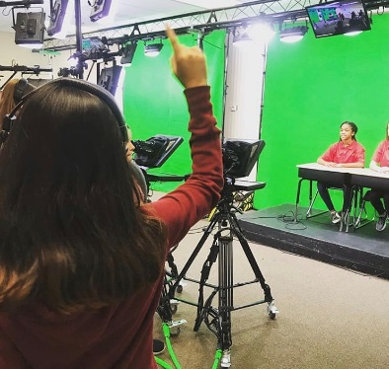
Student Signature: ____________________________________
Parent Signature: ____________________________________

STEP 6: Anchor Person | Field Reporter Costume
If casted as an on camera Anchor Person or Field Reporter, students will be asked to wear our SPARTANTV media shirt. This Shirt will remain in the studio and on the Sunrise Campus the entire year.
Student Signature: ____________________________________
Parent Signature: ____________________________________
STEP 7: SPARTANTV T-Shirt Purchase
A SPARTANTV T-Shirt will be created and each member of the crew must purchase a T-Shirt. When filming on campus, TV crew members will be required to wear the T-Shirt so we look like a professional organization. The price will be around $10.00 per shirt.
Student Signature: ____________________________________
Parent Signature: ____________________________________
STEP 8: Material Fee
There is no Materials Fee this year, but that might change for the 2020-2021 school year. If you become a member of the SPARTANTV Staff, you know that next year there might be a charge for participating.
Student Signature: ____________________________________
Parent Signature: ____________________________________
STEP 9: Leadership Priorities
Please understand that Mr. Harding manages this program so students can have a TV Studio experience. His traditional classroom is his first priority and he must maintain curriculum lessons all year. Please don’t disturb the classroom for STARTANTV questions or concerns. Alternatively, email him at tharding@egusd.net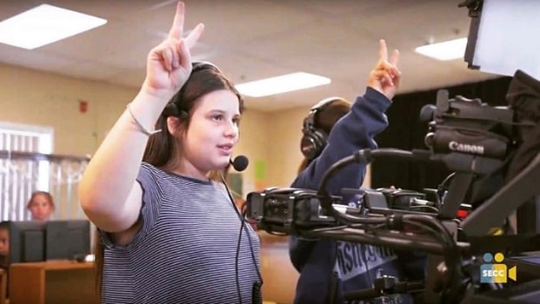
Student Signature: ____________________________________
Parent Signature: ____________________________________

STEP 10:
Select which area you are interested in. Please only select 3 and rank them from 1, 2, 3 of importance. 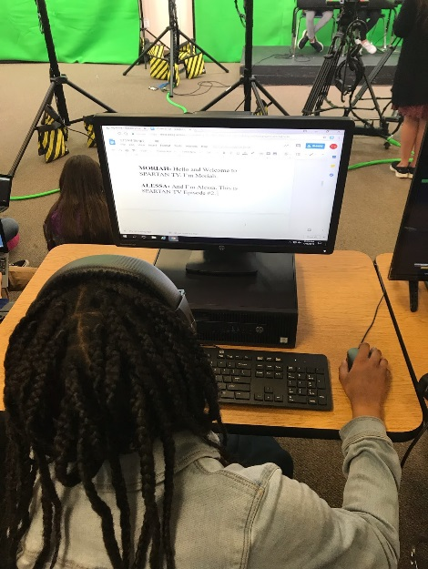

ON CAMERA
Lead Anchor X2 ____
Weather Reporter ____
Traffic Reporter ____
Sport Reporter ____
Field Reporter X4 ____

CREW 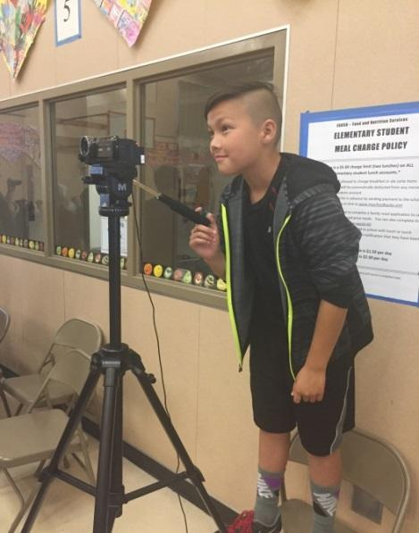
Episode Director ____
Episode Producer ____
Lighting ____
Sound ____
Filming ____
Computer Editing ____
Set/Location Designer ____
Special Note: If you do not want to appear on camera, SPARTANTV will need students to work the crew. Camera, lighting, sound, computer editing training will be given, once you have been selected. SPARTANTV members are selected by your application, essay, teacher approval, and interview. Parents, please let students fill out their own applications.
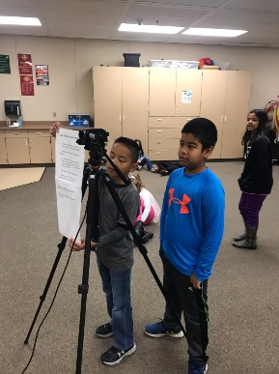
STEP 11:Essay
Write an essay as to why you want to be a member of SPARTANTV. Tell us who you are, what your interests in life are, how you work well with others, and any experience you have had with acting or crew. This essay is designed to get to know you better. Parents please let students write their own essay. Essays will be screened based on your grade level.
________________________________________________________________________________________________________________________________________________________________________________________________________________________________________________________________________________________________________________________
________________________________________________________________________________________________________________________________________________________________________________________________________________________________________________________________________________________________________________________________________________________________________________________________________________________________________________________________________________________________________________________________________________________________________________________________________________________________________________
________________________________________________________________________________________________________________________________________________________________________________________________________________________________________________________________________________________________________________________
________________________________________________________________________________________________________________________________________________________________________________________________________________________________________________________________________________________________________________________________________________________________________________________________________________________________________________________________________________________________________________________________________________________________________________________________________________________________________________
________________________________________________________________________________________________________________________________________________________________________________________________________________________________________________________________________________________________________________________
________________________________________________________________________________________________________________________________________________________________________________________________________________________________________________________________________________________________________________________________________________________________________________________________________________________________________________________________________________________________________________________________________________________________________________________________________________________________________________________________________________________________________________________________________________________________________________________________________________________________________________________________________________________________________________________________________________________________________
__________________________________________________________________________________________________________________________________________________________________________________________________________________________________________________________________________________________________________________________________________________________________________________________________________________________________________________________________________________________________________________________________________________________________________________________________________________________________________________________________________________________________________________________________________________________________________________________________________________________________________________________________________________________________________________________________________________________________________________________________________________________________________________________________________________________________________________________________________________________________________________________________________________

