Positive Behavior Intervention and Supports (PBIS)
at Toby Johnson Middle School

Teacher Packet

PBIS is designed to help create an environment to prevent the development and occurrence of problem behaviors and, more importantly, to teach and encourage prosocial skills and behaviors to students. The staff at Toby Johnson understands the need for a safe and positive learning environment. At Toby Johnson, student expectations for behavior are categorized under our four school rules: Be Safe, Be Respectful, Be Responsible and Be Kind. Our students are given explicit instructions and lessons on how to follow school rules in order to help them practice the skills necessary to be successful students and citizens at Toby Johnson.
 | Be Safe means… | Be Respectful means… | Be Responsible means… | Be Kind means…
Expected Student Behavior | “I keep my hands, feet, and objects to myself. I follow routines and procedures.” | “I use appropriate language and volume levels. I respect people and property.” | “I leave areas clean and am accountable for my actions.” | “I use kind words and actions. I am helpful.”

Why do School-Wide Positive Behavior Interventions and Supports (PBIS) work?
Research shows that when a school environment is positive and predictable, students feel safer, have better academic performance and higher test results, and make better behavior choices. Schools also show a gain in instructional time, a reduction in out-of-school suspensions and discipline referrals, and a decrease in referrals to special education. In addition, PBIS provides us guidance in teaching desired behaviors, recognizing and rewarding desired behaviors, and developing the progression of interventions for behavior infractions.
Is PBIS a curriculum?
No. PBIS is not a curriculum, but a process of planning and problem solving that includes direct teaching of social behaviors similar to how we teach academics. The basic PBIS approach is to use proactive, research-based strategies to teach clearly defined behavior expectations. Most importantly, it establishes ongoing behavior supports that can be used by ALL students, staff, volunteers, parents and community members.
What are the responsibilities of the staff at Toby Johnson in regards to PBIS implementation?
Each staff member is responsible for the behavior of our students. It takes all of us to create an environment where students are Safe, Respectful, Responsible and Kind. Part of this responsibility is to systematically teach the expected behaviors that we all agree will help make our school the best that it can be.

TJMS PBIS Expectations

How long should it take to teach the behaviors in the matrix?
We will have a student assembly and school-wide kickoff event to introduce the behavior expectations and Jag Swag. You should plan to teach and reinforce classroom and school-wide expectations explicitly and directly during the first two weeks of school and then come back to them for refreshers during the next few weeks. TJ-TV and Advocacy will focus on the behavior expectations the first few weeks of school. We want the behavior expectations well understood by all students as we finish the month of August and enter the month of September.

And then I’m done, right?
Not quite. You should plan to teach the “booster lessons” throughout the school year. If a lot of problems arise in a certain situation, re-teach the expectations. Having a new student enter the class is also a perfect time for a “refresher” course.

What do you mean by “teach” the expectations? I always go over the class rules.
This is a little different. By teach we mean show, as in model, demonstrate or role-play. Have the students get up and actually practice exactly what you have shown them to do. Have fun with it! Use the Classroom Behavior Expectations chart to guide your skits or role-plays. Consider using a fishbowl routine or using cards to pull specific scenarios for students to act out. Give students feedback along the way on how they did. Lastly, praise students for their effort (and reward them for doing well). Consider handing out tickets to those students or groups that volunteer to showcase a skit.

Repeat this process as often as it takes for students to learn the behavioral expectations. The idea is to teach behavior the same way we teach academics, and we all know how important practice is for the mastery of academics.

If you notice students exhibiting negative (non-example) behavior inside the classroom during instruction, give yourself permission to stop instruction and address the behavior. Use the moment to help remind all students of expected behaviors. Avoid specifically or directly calling out individual students or drawing the class’s attention to a specific student. Instead, address the whole class and solicit positive examples of expected behaviors. Ask students to show the class what the behavior should look like. Praise and reward students accordingly.

How much time am I supposed to commit to this?
Keep the lessons brief; 5-10 minutes per lesson should be enough. We will devote several Advocacy lessons to expected school-wide behaviors, but it is critical that you consistently and frequently remind and reinforce classroom expectations with your students.

How long should it take to teach the behaviors in the matrices?
You should plan to teach the expectations over the first few days of school and then continue to revisit them for the first two to three weeks. Lessons will need to be repeated and the expectations will need to be strongly reinforced throughout the year.

How often should I teach the matrix behaviors through the remainder of the school year?
As problems arise in certain areas or time of the day, re-teach the expectations for that location or time. We need to make sure that our students get enough practice in demonstrating the positive behavior expectations so that those expectations become second nature and the students actually use them when we are not around.

Jaguar Nation
General Expectations Practiced with and Taught to Students

- Saying “please” and “thank you”, “excuse me” , and “I’m sorry”
- How to enter the classroom
- How to start the day / get to work right away
- How to work independently
- How to work in a group
- What to do if you need help/materials
- What to bring to class
- How to ask questions and why it’s important to do so
- What to do if the teacher is busy or speaking to someone
- What to do if you were absent
- How to give the teacher your attention
- What to do with homework
- How to pass in papers
- How to proceed to the cafeteria, student store, and speed lines for lunch
- How to proceed and enter the gym for an assembly
- How to treat other students and ALL staff respectfully
- How to work with para-educators and support staff
- How to behave appropriately during passing periods
- How to move around campus in a line
- How to move appropriately while walking around the school independently
- How to cleanup and pack up at the end of the day
- What are the dismissal expectations/moving to the gates to exit
- How to behave appropriately before school and after school
- What are the expectations regarding hats/hoods
- What to do with phones upon entering campus
- What is the rule regarding gum chewing on campus
- What are the rules regarding food consumed between classes and outside of the cafeteria during lunch (food purchased at the snack bar and inside speed lines must be consumed in cafeteria)
- What are the expectations for students when the bell rings (must be in line or inside the classroom)

Jag Swag
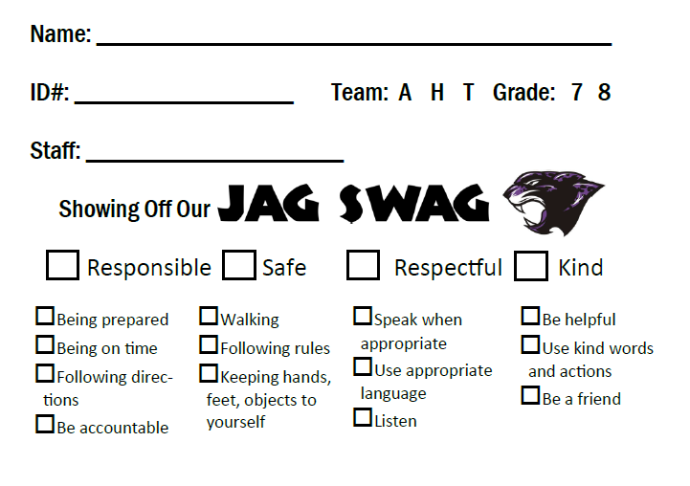
What makes a good reward?

1. Readily available
2. Appropriate to the environment
3. Easy to deliver
4. Can be controlled by the teacher
5. Is powerful to the student

Don’t forget! Positive teacher attention works!
How often should I give positive attention? 5:1
Five positives to one correction establishes a positive tone in your classroom. Remember that students are affected by your interactions with other students in addition to the interactions they directly have with you.

JAG SWAG TICKETS

Jag Swag tickets will be given to students for demonstrating our PBIS behavior expectations (safe, respectful, responsible, and kind) by any teacher/staff member. Jag Swag tickets are pieces of paper that carry a positive message and require recipients to write their name and ID number. The tickets are given to students to recognize when they have performed positive behavior expectations identified in the matrix.

Teachers will receive a stack of Jag Swag tickets at the beginning of year in addition to the ticket template. Please copy additional tickets as needed. Tickets should be copied using white paper only. Separate colored-coded tickets will be used to recognize positive behavior during assemblies and lunch. Copies of the colored-coded Jag Swag tickets used for assemblies will be placed in your boxes prior to the assembly.

The ways we can use them to shape student behavior are outlined below.

Class
- Teachers give tickets to students who demonstrate safe, respectful, responsible, and kind behavior. Teachers make sure to write in their name and check the appropriate boxes. Comments are optional.
- Students put their name, ID#, grade and appropriate team. Students then place their ticket in the appropriate team box in the cafeteria.
- Team boxes are collected daily.
On Campus
- Staff members give tickets to students who demonstrate safe, respectful, responsible, and kind behavior. Staff members make sure to write their name and check the appropriate boxes. Comments are optional.
- Students put their name, ID#, grade and appropriate team. Students then place their ticket in the appropriate team box in the cafeteria.
- Team boxes are collected daily.

Lunch
- Staff members give lunch-specific tickets to students who demonstrate safe, respectful, responsible, and kind behavior during lunch. Staff members make sure to write their name and check the appropriate boxes. Comments are optional.
- Students put their name, ID#, grade and appropriate team. Students then place their ticket in the appropriate lunch time box in the cafeteria.
- Every Wednesday and Friday, staff will pull out 5 names at each lunch. Those students receive a prize.
Assemblies
- Staff members/teachers give assembly-specific tickets to students who demonstrate safe, respectful, responsible, and kind behavior during assemblies. Staff members/teachers make sure to write their name and check the appropriate boxes. Comments are optional.
- Students put their name, ID#, grade and appropriate team. Students then place their ticket in the appropriate assembly box in the cafeteria.
- The assembly box is collected that day, student winners will be announced the following morning on TJTV.

Jag Swag tickets will be pulled each morning during TJ-TV. Teachers will release students during TJ-TV to come to MC 9 and claim their prize. Students must be present to win and must have their ID. If a student is absent, they will still be eligible for future drawings. Administration will make an announcement over the public address system at the end of the day with the names of those students who did not claim their prize during TJ-TV.

Toby Johnson Acknowledgment System
 | Jag  Swag Tickets | Student of the Month | Team Term Awards | Good News Postcards | Daily  Raffle | Weekly Raffle | Monthly Tardy Raffle | Friday ¨Pick Me Up¨ | Movie Night
What? | Each teacher/staff member is given Jag Swag tickets to give to students following the expectations. | Teams select students each month. Students get pizza lunch. | Teams select students at the end of each term. Teams provide variety of activities. | Teachers and staff members write notes to students that mailed home | Two tickets per grade level, per team will be pulled during TJ-TV each morning. Students must be present to win.✶ | Five lunch tickets are pulled twice a week on Wednesdays and Fridays. | One class per team is randomly selected. One student per class is randomly selected that has no tardies. Each student is awarded a $5 gift card. | Each Friday, Administration randomly selects a teacher/staff member who has worked hard on a given task for the week. The teacher/staff member is given a beverage of his/her choice. | Students get free admission to a movie at school. This may include popcorn or sundaes.
Who gives it? | Teachers/  Staff to students | Teachers/  Staff to students | Teachers to students | Teachers/staff to students | Teachers/  staff to students | Teachers/  staff to students | Admin to students | Admin to teachers/  staff | Admin to students
How often? | All day, every day  Daily, weekly and monthly drawings | Monthly | Quarterly | Ongoing | Daily | Twice a week | Monthly | Weekly | Quarterly
Cost | $50 | $100 | $50 | Cost of printing/postage | $150 | $50 | $30/month | Money donated by Parent  Group | $100

NOTE: Jag Swag tickets will be issued during Assemblies and other special events.

✶Jag Swag tickets will be pulled each morning during TJ-TV. Teachers will release students during TJ-TV to come to MC 9 and claim their prize. Students must be present to win and must have their ID. If a student is absent, they will still be eligible for future drawings. Administration will make an announcement over the public address system at the end of the day with the names of those students who did not claim their prize during TJ-TV.

Toby Johnson Referral Completion Guidelines

An integral part of PBIS is that all behavior interventions need to be tracked and documented. We must be able to determine areas of concern and improvement. The data inputted into SISWEB will provide accurate information on students that may be referred to a higher level of support.

Process required for documenting Behavior Events and Interventions:
1. Log into SISWEB
2. Go to PBIS tab and click on Event Entry
3. Type in student’s number or look them up by name and click submit
4. The student’s information will come up. Click on Add Event or Add Intervention
5. Incident Date must be accurate
6. For Events:
a. Fill in Reported By and Level (minor or major)
b. Use drop down to pick the Problem Behavior, Time, Location, Perceived Motivation
and whether others were involved
c. Fill in incident details
7. For Interventions:
a. Fill in Description box
8. Click on Insert and then Commit
9. Once the commit button has been pressed, you are now taken back to the screen that shows the
list of incidents of the student
10. Note the option to email. In addition to calling the parent/guardian, you have the option to email them
and other staff members as well

The following is a general outline of the Referral/Time out process:
1. Student is sent to the office with a pass indicating a referral has been written (or will be written
shortly) and with work for the student to complete.
a. Appropriate example of description of behavior:
Mark was talking out during other students’ project presentations. He was given numerous verbal warnings and nonverbal gestures to keep him on task. I asked if he needed to step outside and compose himself, he said he didn't. I asked him if he had his squish ball to help him focus and he said he didn't. I offered him a stress ball, which he used to distract the student next to him. He then used his pencils to make loud noise. I made sure he was aware that I had already given him several warnings and if he did it again I was going to send him out because it was disrupting the learning environment of the classroom. He continued and was sent to the admin team.
b. Non-example:
Mark disrupted the learning environment
c. The referring teacher logs the Behavior “Event” in SISWEB
d. The referring teacher calls home by the end of the day and enters a new SISWEB
“intervention” to document the parent/teacher conversation
Example entry: I called and spoke with Mark’s mother regarding Mark’s constant disruption during today’s class. During class, Mark constantly distracted student presenters as well as students in the audience. Despite verbal warnings, nonverbal gestures, and additional attempts at redirection, Mark continued to disrupt the learning environment. Mark was sent to the office. Mark’s mother informed me that she will speak to Mark regarding this incident.

2. The student is sent to the office with a pass indicating that they need a “time out” and may or may not
have work to complete.
a. Admin will send the student back to class with a pass after no more than 15 minutes.
b. Admin logs Administrative Conference in SISWEB
c. The referring teacher logs Behavior Event in SISWEB
d. The referring teacher calls home by the end of the day and enters a new SISWEB
“intervention” to document the parent/teacher conversation

Class Suspension Assigned by Teacher
1. Teachers suspending a student from class will use the PBIS tab and click on Add Event. Click on Add
Class Suspension and fill-in/complete appropriate fields.
2. NOTE: PURSUANT TO EDUCATION CODE SECTION 48910: AS SOON AS POSSIBLE THE
TEACHER SHALL ASK THE PARENT OR GUARDIAN OF THE PUPIL TO ATTEND A PARENT-
TEACHER CONFERENCE REGARDING THE SUSPENSION.
3. Teacher must contact parent by phone and have a phone conference or schedule a PTC upon
assigning a class suspension.

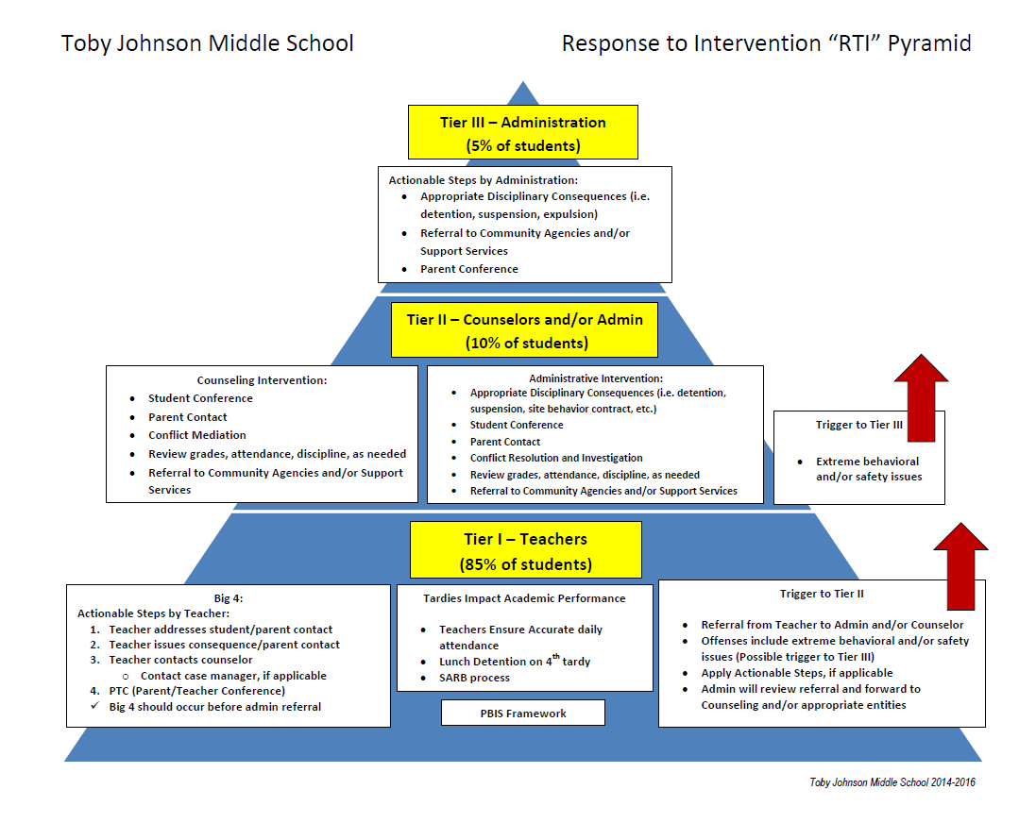

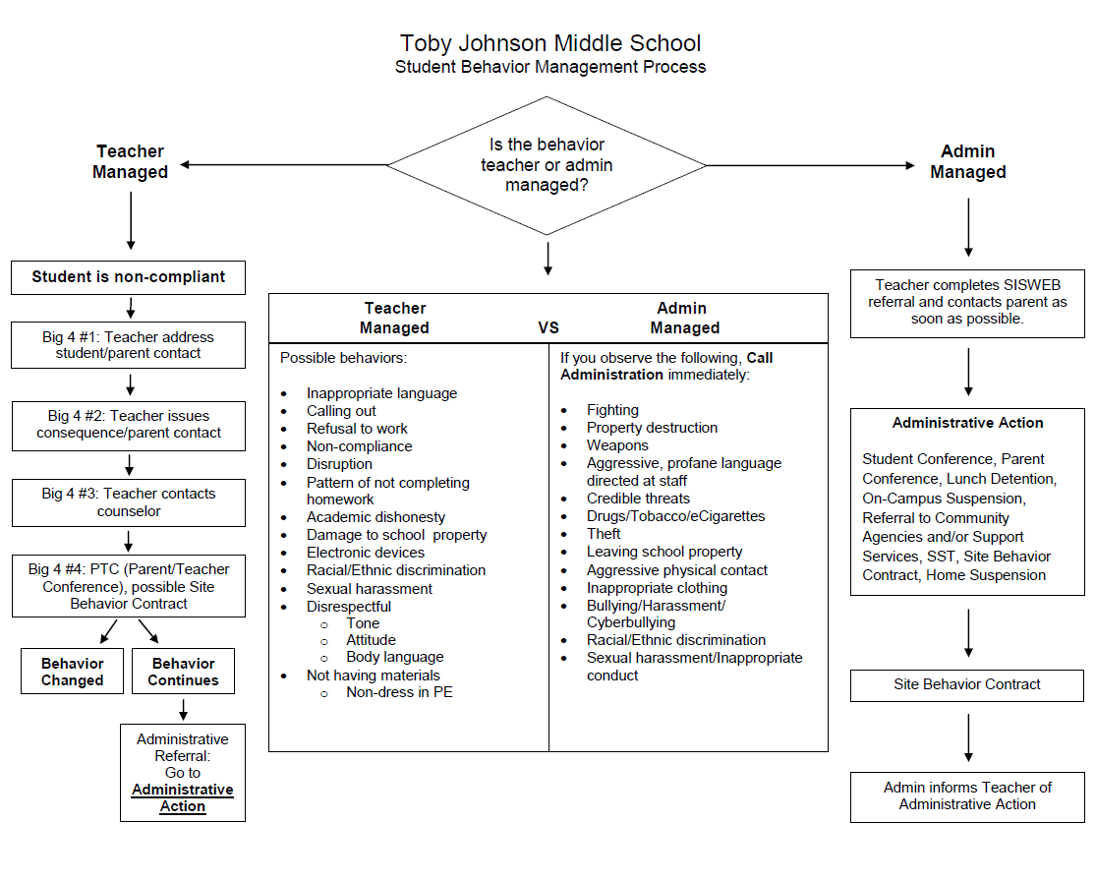

Classroom Expectations Matrix
School rules | Be Safe |  | Be Respectful | Be Responsible | Be Kind
Expected student behavior | “I keep my hands, feet, and objects to myself. I follow routines and procedures.” |  | “I use appropriate language and volume levels. I respect people and property.” | “I leave areas clean and am accountable for my actions.” | “I use kind words and actions. I am helpful.”
Classroom Routines/Behavior Expectations
Entering the Classroom |  | How can students be welcomed to the class?
Starting the Day |  | How can instruction begin quickly?
Attention Signal |  | What attention signal will be used?
Working Independently |  | What are the expectations for students when they are working independently?
Working in Groups/Collaboratively |  | What are the expectations for students when they are working in groups/collaboratively?
Asking for Help |  | How will students ask adults for help?
Working with Para Educators/Support Staff |  | How will students work with para educators and respond to additional classroom support?
Exiting the Classroom |  | How can students prepare to leave the classroom?

Classroom Expectations Matrix
School rules | Be Safe |  | Be Respectful | Be Responsible | Be Kind
Expected student behavior | “I keep my hands, feet, and objects to myself. I follow routines and procedures.” |  | “I use appropriate language and volume levels. I respect people and property.” | “I leave areas clean and am accountable for my actions.” | “I use kind words and actions. I am helpful.”
Classroom Routines/Behavior Expectations
Hats in the Classroom |  | What are the expectations for students wearing hats?
Hoods in the Classroom |  | What are the expectations for students wearing hoods?
Phones in the Classroom |  | What are the expectations for cell phones?
Gum in the Classroom |  | What are the expectations for gum chewing?
Food Outside the Classroom |  | What are the expectations for students eating outside your classroom?
Food Inside the Classroom |  | What are the expectations for food inside the classroom?
Walking on the Grass |  | What are the expectations for students walking on the sidewalks and areas with grass?
Tardy Policy |  | How will students know when they are tardy? What are the expectations when students are late to class?

Classroom Expectations Matrix
School rules | Be Safe | Be Respectful | Be Responsible | Be Kind
Expected student behavior | “I keep my hands, feet, and objects to myself. I follow routines and procedures.” | “I use appropriate language and volume levels. I respect people and property.” | “I leave areas clean and am accountable for my actions.” | “I use kind words and actions. I am helpful.”
Entering the Classroom
Starting the Day
Attention Signal
Working Independently
Working in Groups/Collaboratively
Asking for Help
Working with Para Educators/Support Staff
Exiting the Classroom

Classroom Expectations Matrix
School rules | Be Safe | Be Respectful | Be Responsible | Be Kind
Expected student behavior | “I keep my hands, feet, and objects to myself. I follow routines and procedures.” | “I use appropriate language and volume levels. I respect people and property.” | “I leave areas clean and am accountable for my actions.” | “I use kind words and actions. I am helpful.”
Hats in the Classroom
Hoods in the Classroom
Phones in the Classroom
Gum in the Classroom
Food Outside the Classroom
Food Inside the Classroom
Walking on the Grass
Tardy Policy

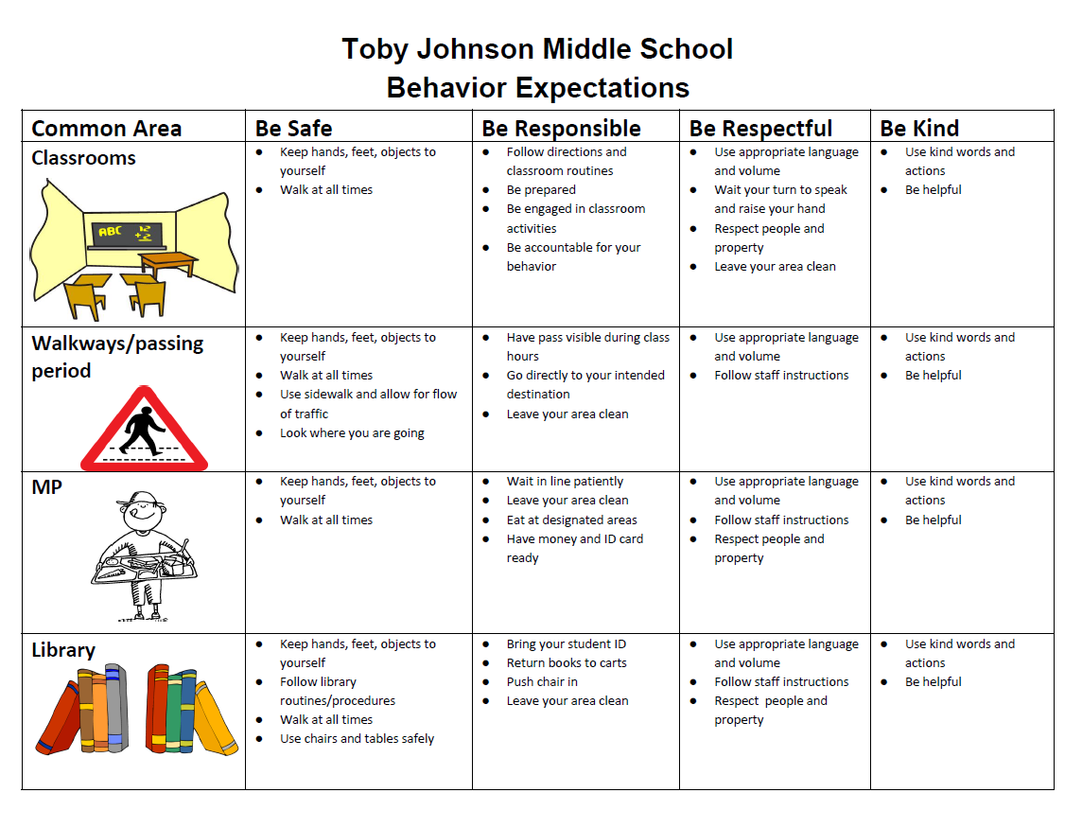
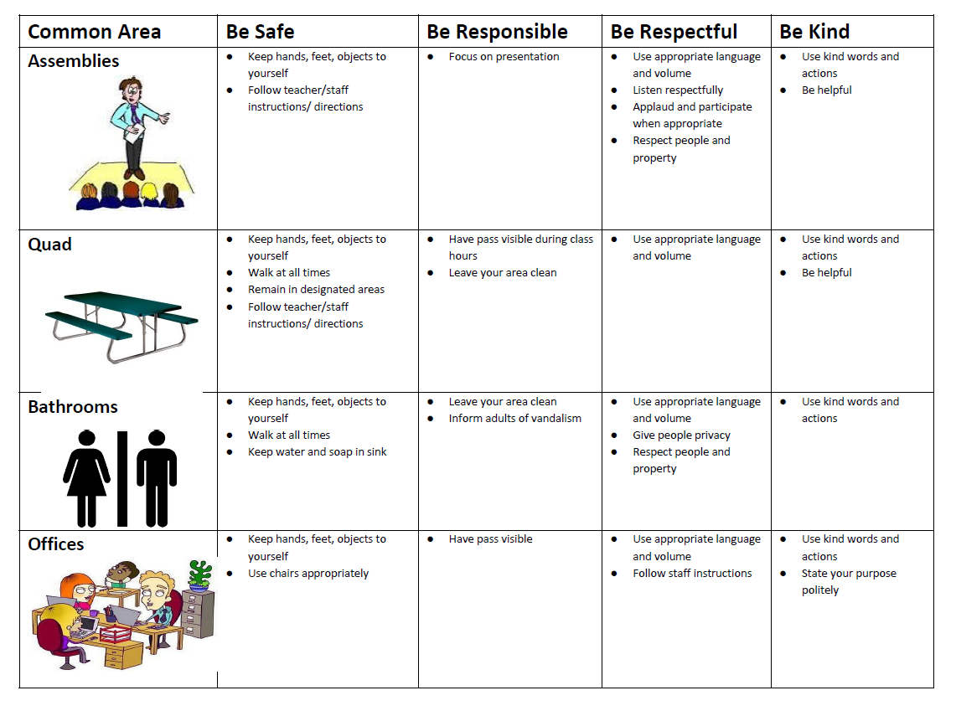

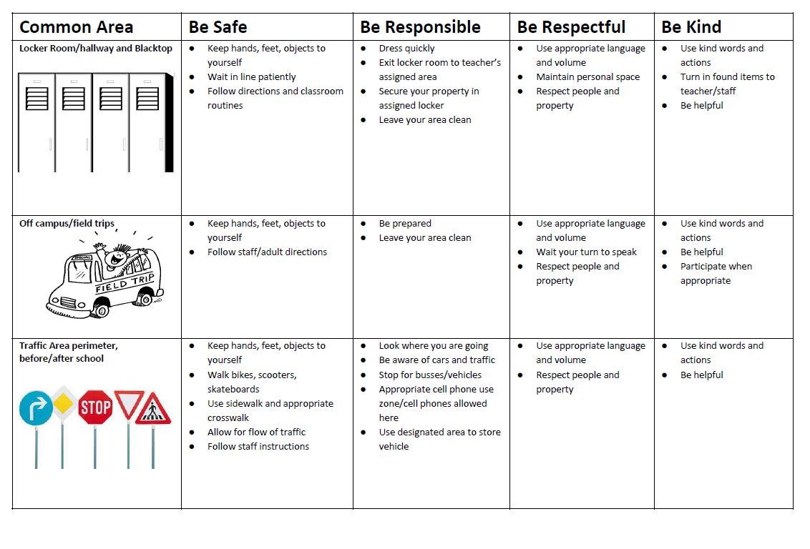

Team: _________ Student: __________________ID#: ___________

Toby Johnson Response to Intervention (RTI) Model
Team/Classroom Interventions

We recognize that interdisciplinary teams provide the foundation to our RTI model. The team acts as the touchpoint to services and resources available on campus that help students be successful. You are the most powerful advocate for students to help provide strategies and support as we move through the RTI model.

In addition to an explicit and consistent classroom management plan that works in conjunction with our PBIS framework, describe additional interventions in place within your classroom:

- Have student sit near an appropriate peer model
- Student in close proximity to staff
- Reduce/minimize distractions
- Predictable daily routine/visual schedule with changes discussed ahead of
time
- Classroom rules are simple, clear, and stated positively and reviewed on an
ongoing basis
- Build a rapport with the student (e.g. ask empathetic questions, find their
interests, encourage)
- Incorporate student strengths/interests into learning
- Build a history of academic success for the student
- Offer structured choices
- Use cues, prompts, and redirection
- Modify/monitor nonacademic times
- Allow short breaks between assignments
- Provide student with opportunity for responsibility
- Focus on the positive, ignoring behavior not drastically outside class limits
- Teach new skills and replacement behaviors
- Provide social reinforcers/positive reinforcement (e.g. praise)
- Provide concrete reinforcement (e.g. stickers, prizes, tickets)
- Utilize self-monitoring devices (e.g. stress ball)
- Provide regular communication with parents/guardians
- Request parent/guardian reinforcement for behavior
- Implement individualized rules and behavior contract
- Other:
_______________________________________________________________________
______________________________________________________________________________________________________________________________________________
_______________________________________________________________________
_______________________________________________________________________
_______________________________________________________________________
_______________________________________________________________________

Team: __________ Student: _________________ ID#: _____________
Toby Johnson Response to Intervention (RTI) Model
Team/Classroom Interventions

Ongoing Interventions and Supports
1. Describe your classroom management plan.

2. How and when are students taught to be safe, respectful, responsible and kind? How are these behavior expectations reinforced?

Use the log below to document specific concerns, interventions, and results.
Dates/  Duration | Concern | Strategy/Intervention | Results | Parent Phone Call

