Monterey Trail High School
Mustang Gold Tickets
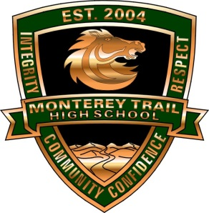

Hey Mustangs!
Have you earned a “We are MT: Mustang Gold Ticket” for demonstrating our CORE VALUES?

INTEGRITY
COMMUNITY
RESPECT
CONFIDENCE

Read here for Mustang Gold Ticket information:

Who can participate? All Monterey Trail High School students can earn “WE ARE MT Mustang Gold” tickets from ANY MTHS Staff Member for demonstrating one or more of the MTHS Core Values: Integrity, Community, Respect, and/or Confidence.

What do I do with the tickets? Fill in your first and last name and ID # and turn the top/white copy to ANY MTHS STAFF MEMBER and they will turn it in for you OR you can personally drop off the tickets to the main office, counseling office, or library.

What will the staff member do with my tickets? Staff members will place the white copy in a collection bucket located throughout the MTHS campus. The collection buckets are located in the department PODs.

Why should I turn in my tickets? Each week, 6 Mustang Gold ticket winners will be selected and receive prizes during 2nd or 3rd period. There will also be winners selected at the end of each term. Prizes may include: MTHS gear, water bottles, lanyards, gym sacks, coupons to the student store, gift cards, and tickets to MTHS events..

What do I do with the GOLD ticket (bottom copy)? Students- please keep the bottom yellow/gold copy to proudly display throughout the school year. Listen to the bulletin for special “Mustang Gold” days when students can get a special treat for displaying their “Mustang Gold” ticket at the ASB window.

PLEASE POST

