Monterey Trail High School
“Mustang Gold” Ticket Instructions

MTHS Staff: ______________________________________ Ticket #’s ________ Room: ______________
Who: All Monterey Trail High School Staff Members can participate in distributing “Mustang Gold” tickets.
What: Each MTHS staff member has the opportunity to recognize students who demonstrate our MTHS Core Values: Community, Respect, Integrity, and Confidence with “Mustang Gold” tickets. See the instructions below.
When: Staff members can distribute “Mustang Gold” tickets at any time: before school, during class, passing periods, lunch, at club meetings, athletic events, and other after school activities. Teachers: please ask your substitutes to leave a list of names of students who were extra helpful during your absence and then you can reward these students when you return the next day.
Where: “Mustang Gold” tickets can be distributed anywhere on the MTHS campus: classrooms, the library, office, etc…
Why: To recognize and encourage positive behaviors at Monterey Trail High School.

Instructions for turning in Mustang Gold tickets:
When you witness and want to recognize positive behaviors, give students a “Mustang Gold” ticket.
Check/Circle 1 or more of the MTHS Core Values displayed on the top of the ticket: Community, Respect, Integrity, and/or Confidence.
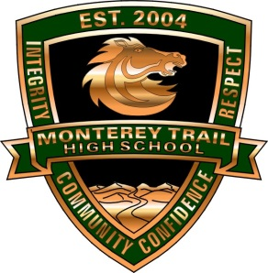
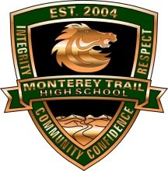
Instruct students fill in their name and ID # & give the top copy (white) to any staff member on campus.
Students keep the bottom copy (yellow) for future recognition that will be announced in the bulletin.
Staff members turn in the top copy to the containers located in each POD or in the front office.
6 student names will be selected each week and the winners will be announced during the Friday bulletin.
Prizes will be delivered to 2nd or 3rd period class each week.
Big ticket prizes and treats (for yellow copy) will be awarded at the end of each term.
Please make your best effort to distribute 6-10 “Mustang Gold” tickets to students on our campus each week.
Do you need more tickets or have questions, comments, or concerns?
Please contact Ramie Gallagher in room HN-10 or email: rgallagh@egusd.net

Monterey Trail High School
“Mustang Gold” Ticket Instructions

MTHS Staff: ______________________________________ Ticket #’s ________ Room: ______________
Who: All Monterey Trail High School Staff Members can participate in distributing “Mustang Gold” tickets.
What: Each MTHS staff member has the opportunity to recognize students who demonstrate our MTHS Core Values: Community, Respect, Integrity, and Confidence with “Mustang Gold” tickets. See the instructions below.
When: Staff members can distribute “Mustang Gold” tickets at any time: before school, during class, passing periods, lunch, at club meetings, athletic events, and other after school activities. Teachers: please ask your substitutes to leave a list of names of students who were extra helpful during your absence and then you can reward these students when you return the next day.
Where: “Mustang Gold” tickets can be distributed anywhere on the MTHS campus: classrooms, the library, office, etc…
Why: To recognize and encourage positive behaviors at Monterey Trail High School.

Instructions for turning in Mustang Gold tickets:
When you witness and want to recognize positive behaviors, give students a “Mustang Gold” ticket.
Check/Circle 1 or more of the MTHS Core Values displayed on the top of the ticket: Community, Respect, Integrity, and/or Confidence.
Instruct students fill in their name and ID # & give the top copy (white) to any staff member on campus.
Students keep the bottom copy (yellow) for future recognition that will be announced in the bulletin.
Staff members turn in the top copy to the containers located in each POD or in the front office.
6 student names will be selected each week and the winners will be announced during the Friday bulletin.
Prizes will be delivered to 2nd or 3rd period class each week.
Big ticket prizes and treats (for yellow copy) will be awarded at the end of each term.
Please make your best effort to distribute 6-10 “Mustang Gold” tickets to students on our campus each week.
Do you need more tickets or have questions, comments, or concerns?
Please contact Ramie Gallagher in room HN-10 or email: rgallagh@egusd.net

