**Family & School Involvement Example**

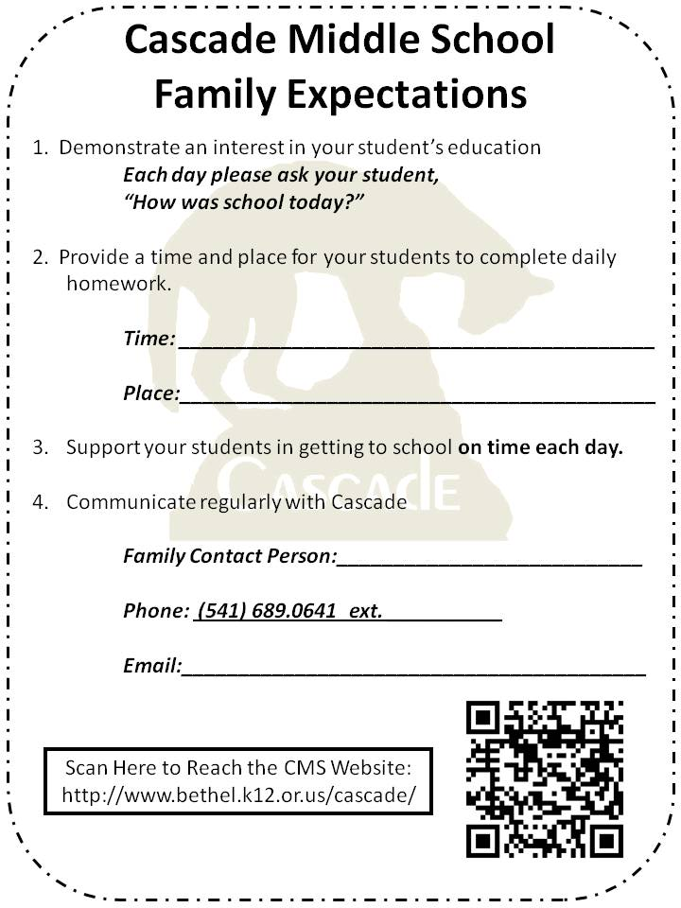

**Cascade Middle School**

**Eugene, Oregon**

**Family Expectations & Contacts**

***Talking Points to Share during phone calls (please call before Tuesday):***

As part of our effort to help students to be successful this year we are asking parents to support four expectations.

1. Show an interest in your student’s education.

***Each day please ask your student, “How was school today?”***

2. Provide a time and place for your students to complete daily homework.

3. Support your students in getting to school **on time each day.**

4. Communicate as needed with Cascade.

Since one of those expectations is that parents maintain communication with CMS as needed to celebrate and support their student, we have asked staff to sign up to be the “Family Contact Person” for everyone family in the building…

You are their family contact person. Please share your email and extension here at Cascade.  ***Also, please clarify that they do NOT need to go through you for all communication and are always welcome to call folks directly as needed. You are just there as a resource if they need.***

Please let them know that magnets are being made (noting the expectations) and will be sent home soon. What is the most reliable way to get that home to the family?

Invitation to Open House on Tuesday at 7:00. Please ask if they will be attending.