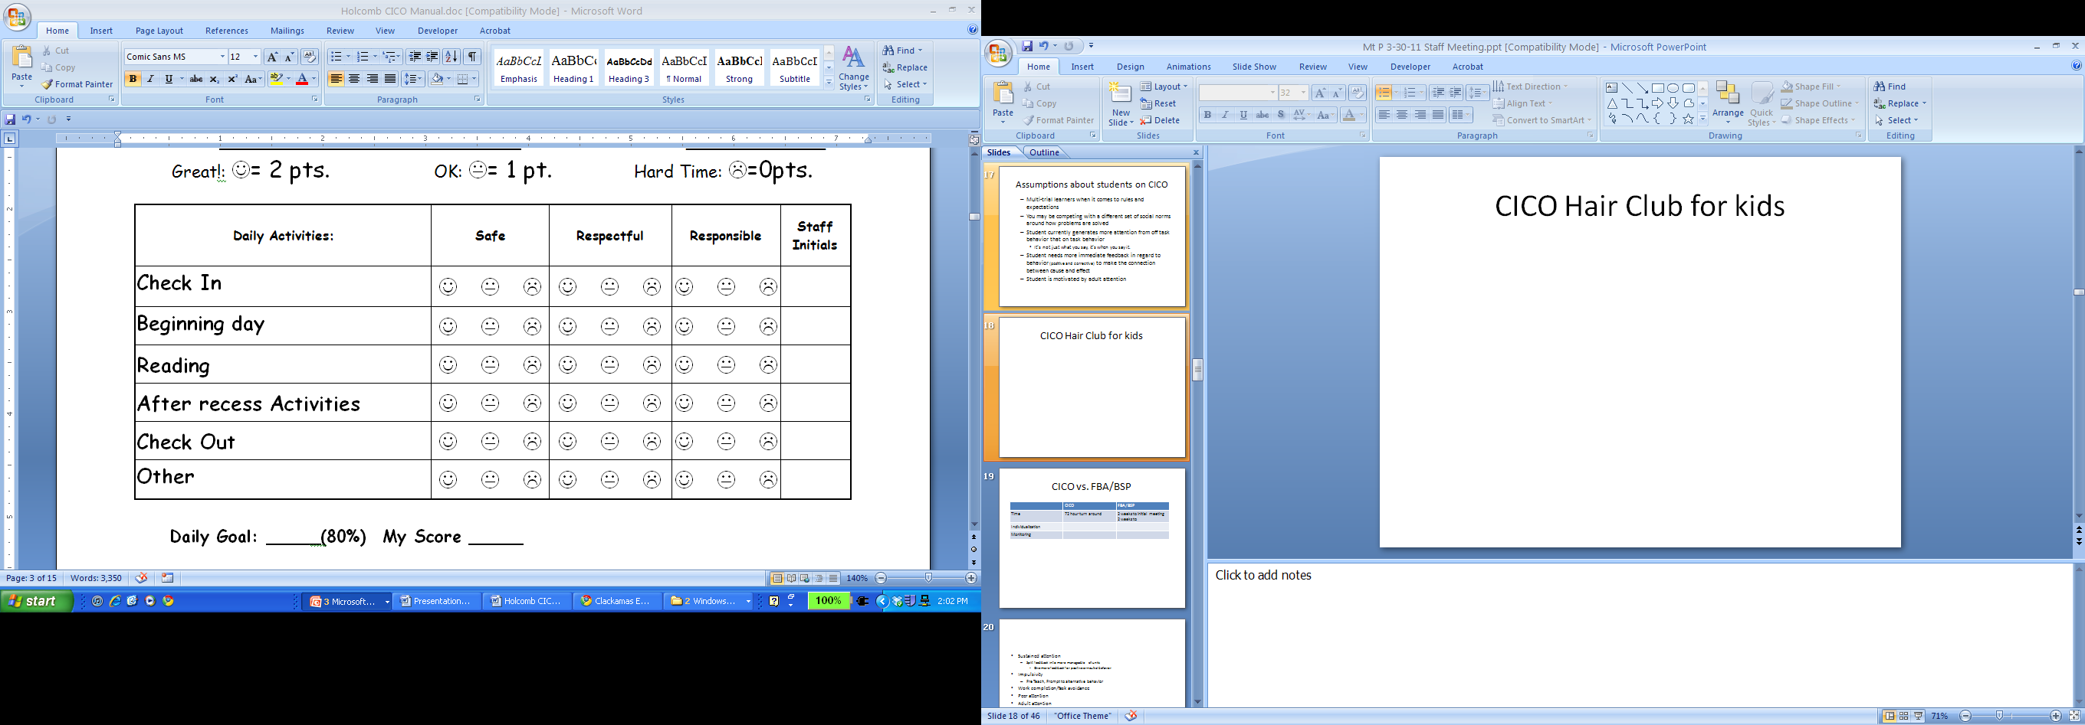

* **Teacher gives more frequent feedback by applying hair – then uses hair to inform overall score for period**
* **Another Alternative – Create alternate card which breaks day into smaller intervals**