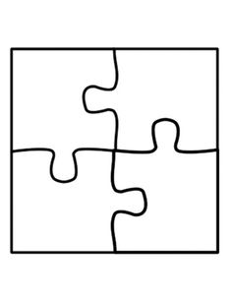
Area Model
Partial Products
Base Ten Model
Standard Algorithm

Mr. Griffin’s backyard is 14ft by 18ft. What is the area of his backyard?

