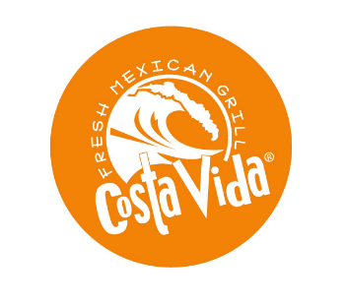
Join the Sunrise Elementary PFO
for a Fundraiser Event
Thursday, August 27th

All Day Long at
Costa Vida- Fresh Mexican Grill
(10831 Olson Dr, Rancho Cordova)

An After School Treat from 3:00pm-6:00pm
Snowflakes Shave Ice
(in the parking lot of Walgreen’s at Sunrise and Herodian)

Please present this flyer with your order at both spots
and 20% of the sale will be donated to Sunrise Elementary.
THANK YOU FOR YOUR SUPPORT!
Questions? Email sunrisepfofundraising@yahoo.com

Join the Sunrise Elementary PFO
for a Fundraiser Event
Thursday, August 27th

All Day Long at
Costa Vida- Fresh Mexican Grill
(10831 Olson Dr, Rancho Cordova)

An After School Treat from 3:00pm-6:00pm
Snowflakes Shave Ice
(in the parking lot of Walgreen’s at Sunrise and Herodian)

Please present this flyer with your order at both spots
and 20% of the sale will be donated to Sunrise Elementary.
THANK YOU FOR YOUR SUPPORT!
Questions? Email sunrisepfofundraising@yahoo.com

