The Smarter Balanced Assessment Consortium (SBAC) practice and training tests are two crucial resources designed to acclimate students to the type of computer based assessments they will experience during the spring summative tests in ELA and Math.
Be aware that the practice tests are substantially different from the training tests. Practice tests simulate a full testing experience with a large number of items and testing length similar to the full test and are available in each grade from 3-8 and 11. Training tests have a very small number of items and are available in the following grade bands: 3-5, 6-8, and 11. Practice tests are most helpful to expose students to grade level appropriate content and simulate operational testing length. Training tests are most helpful to give brief, general exposure to what online testing will be like under CAASPP.
The practice and training tests are unsecured and publicly available; anyone with a computer connected to the internet can use them including: administrators, teachers, parents, students, and community members. The practice and training tests do not generate scores of any kind, but scoring guides for the practice tests are available online at http://goo.gl/feusmx
This simple illustrated guide is intended to help with accessing the practice and training tests.
NOTE: The ELA practice/training tests require headphones
Step 1. Open the Chrome browser from your desktop.
Step 2. Enter “caaspp.org” in the address bar (highlighted in red) and press “enter”.
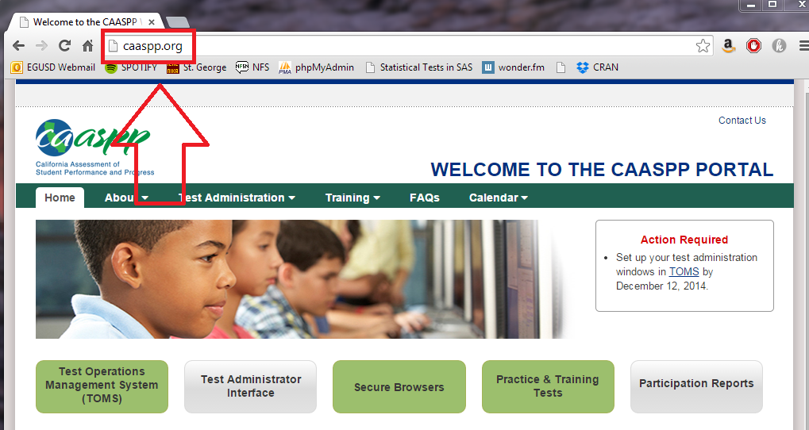

Step 3. Click the “practice & training tests” button (highlighted in purple)
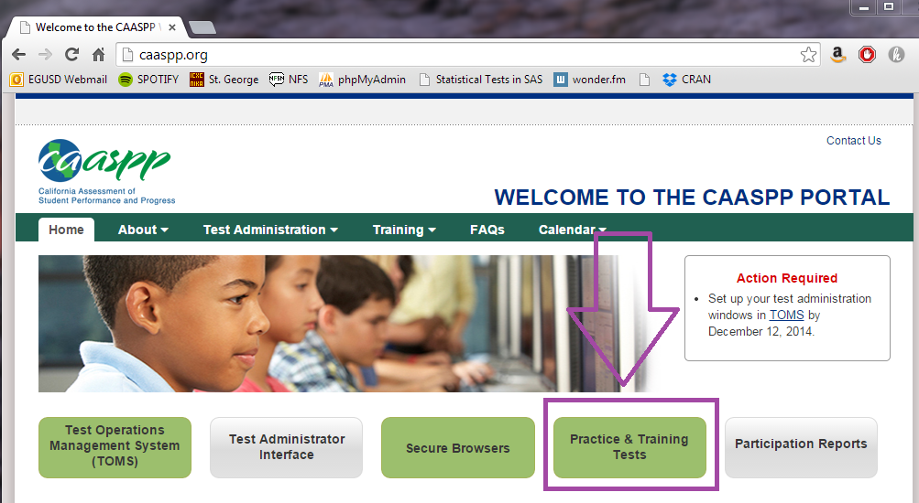
Step 4. Click the green button for “Student Interface Practice and Training Tests” (highlighted in orange)
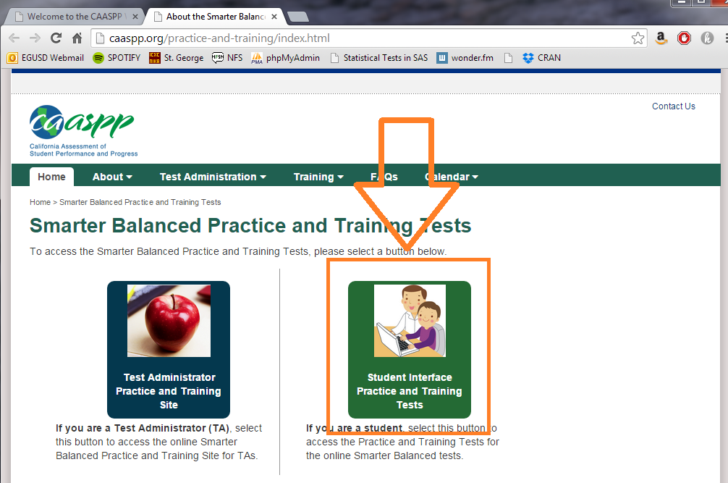

Step 5. Leave the guest user and session as is. Currently the testing database isn’t populated with student log-in information, so students have to log in as guest. Click the “sign in” button (highlighted in red).
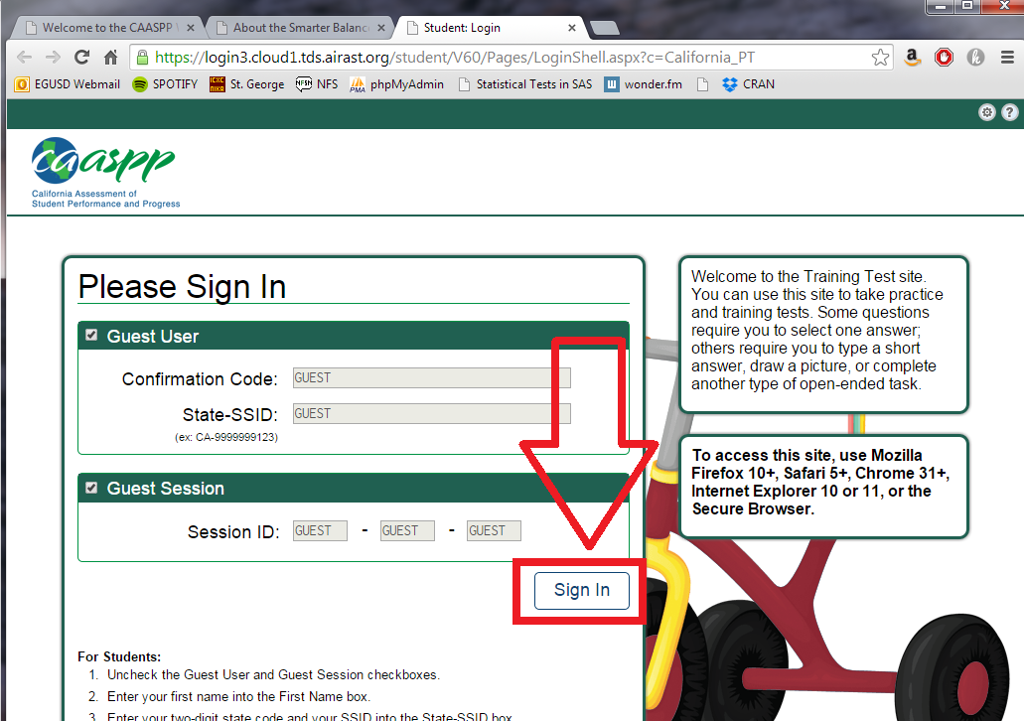
Step 6. Choose the appropriate grade (highlighted in green)—this decision will determine practice/training test selection—then click “yes” (highlighted in purple).
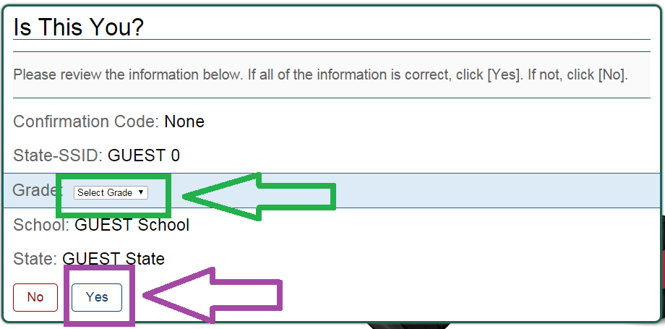

Step 7. Choose a test. The tests highlighted in red are the short training tests. The tests highlighted in orange are the full length practice tests. The tests highlighted in purple are sample performance tasks. When you’ve made a decision, click the test you’d like to take.
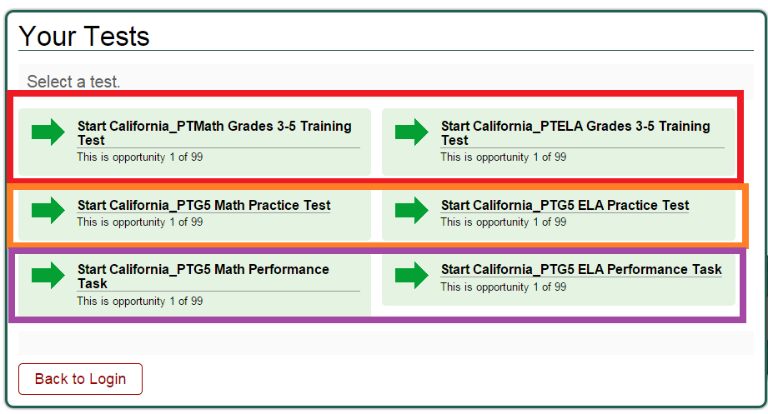
Step 8. Most students will not need or benefit from modified settings. If you feel they would benefit a particular student, you can make changes, otherwise just click “select” (highlighted in red)
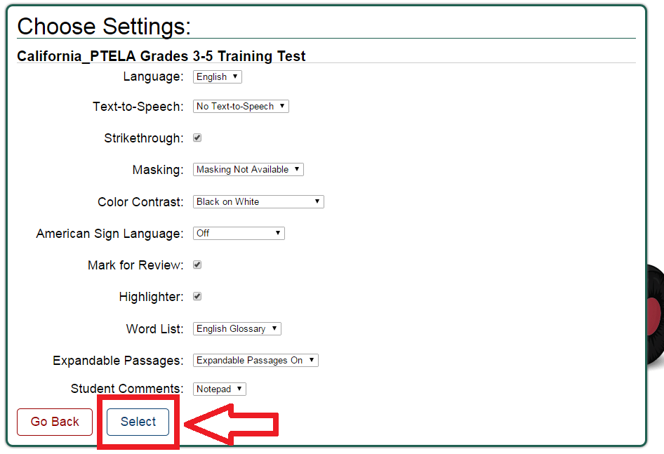

Step 9. Click the “yes, start my test” button to proceed.
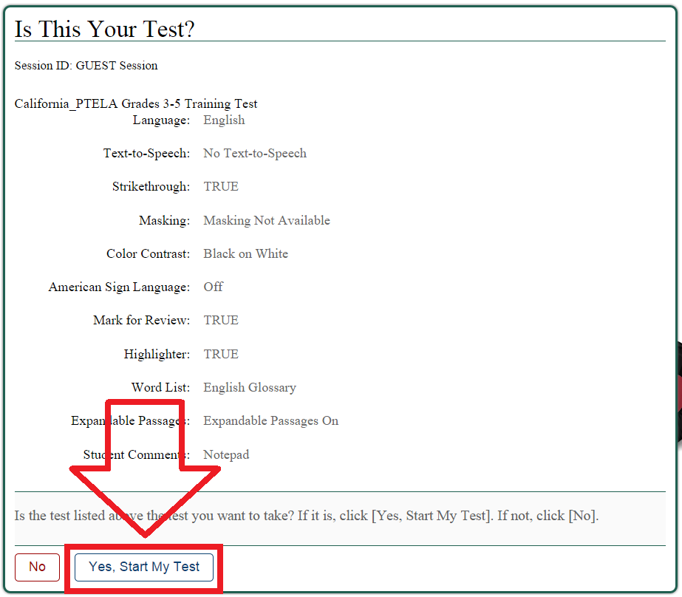
Step 10. T
he ELA tests contain listening portions. You will be required to complete a sound check to ensure that you can access this content. Click the speaker icon (highlighted in orange) and then click the “yes” button (highlighted in red)
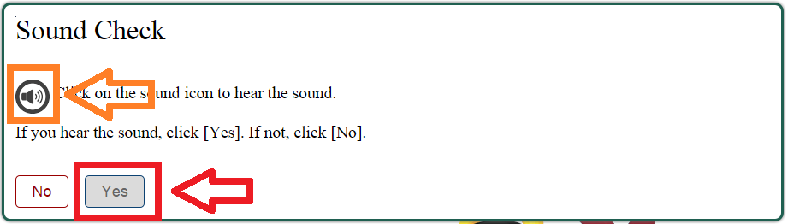

Step 11. Review test instructions and then click “begin test now” (highlighted in green)
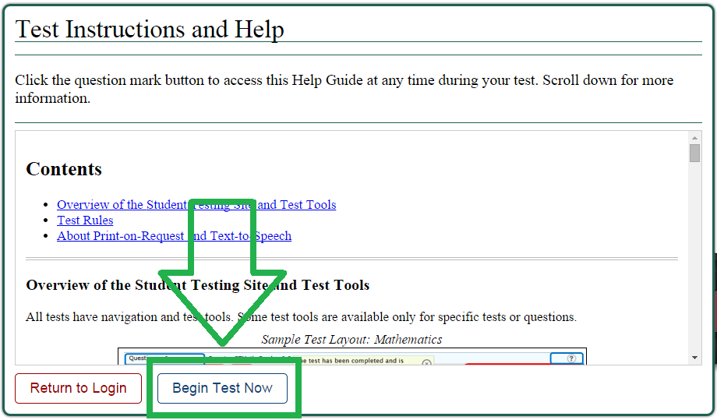
Step 12. You have reached the test! Complete all the questions on each page, then click the “next” button in the upper left hand corner to advance to the next page of questions.

