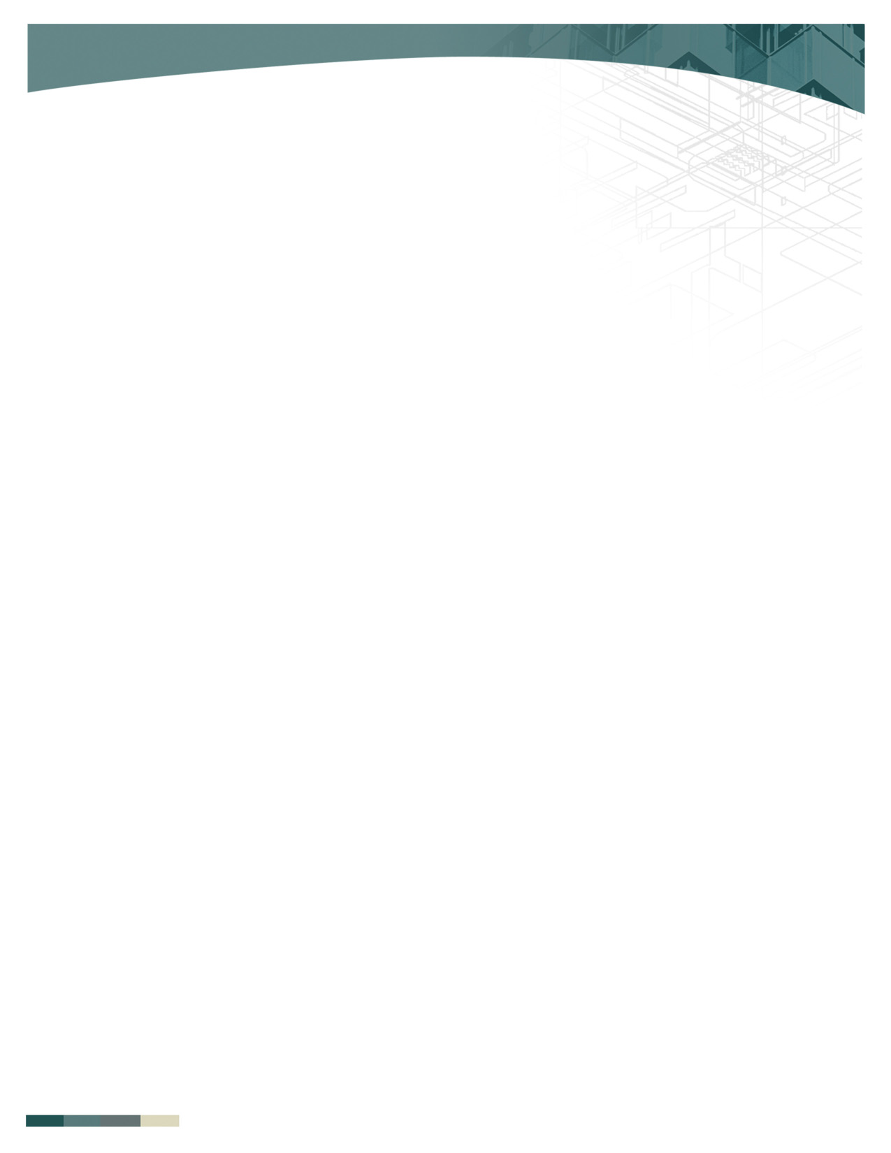­

**Elk Grove Unified School District Phases of Implementation (POI)**

**N P F (N=not in place P=partially in place F=fully in place)**

**Tier 1 Phase 1**

⬜ ⬜ ⬜ School staff complete Self Assessment Survey annually

⬜ ⬜ ⬜ PBIS Team solidified, roles defined for each member, and monthly meetings scheduled.

⬜ ⬜ ⬜ School-wide staff presentation completed.

⬜ ⬜ ⬜ Staff consulted at each step in the development of PBIS (regular feedback on essential elements)

⬜ ⬜ ⬜ PBIS is a standing item on agenda (10-15 min) for all staff meetings (classified and certificated)

⬜ ⬜ ⬜ Staff Feedback System Formalized (for decision making)

⬜ ⬜ ⬜ Behavioral Matrix completed for all settings. (i.e. classroom, hallways, cafeteria, bathrooms, gym, etc.)

⬜ ⬜ ⬜ 3-5 School-wide Rules in place and agreed upon.

**Tier 1 Phase 2**

⬜ ⬜ ⬜ Lesson plans are written for teaching expected behaviors in all school settings.

⬜ ⬜ ⬜ Scheduled dates for teaching PBIS expectations (1x month)

⬜ ⬜ ⬜ Posters with expectations are posted in common areas that are relevant to each setting.

⬜ ⬜ ⬜ Student Acknowledgement/Reward System is established and linked to school rules.

⬜ ⬜ ⬜ Staff Acknowledgement/Reward System is established and linked to school rules.

⬜ ⬜ ⬜ Funding for Acknowledgements/Rewards is secured.

**Tier 1 Phase 3**

⬜ ⬜ ⬜ Behavior Definitions have been completed, including agreement on specifics for minor/major problem behaviors.

⬜ ⬜ ⬜ Office Discipline Referral form is completed and includes data points necessary for SISWeb entry including minor/

major delineation.

⬜ ⬜ ⬜ Staff managed/Office managed flowchart completed.

⬜ ⬜ ⬜ Staff has had input and agreed upon the process and implementation of the Student Behavior Management Flowchart.

⬜ ⬜ ⬜ SISWeb Readiness completed, including staff training of data entry.

⬜ ⬜ ⬜ SISWeb data entry process determined. (Who? When?)

Team Signatures:

____________________________________ ______________________________________ __________________________________

____________________________________ ______________________________________ __________________________________ ____________________________________ ______________________________________ __________________________________ 1/11/17