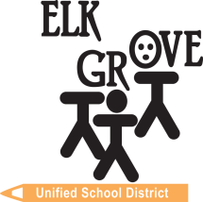­

**PBIS Tier 1 Recap &**

**Tier 2 Readiness**

**Team Training**

**Resource Packet**