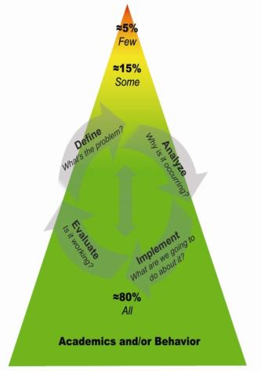

**Tier III: _________________________**

**_________________________**

**_________________________**

**_________________________**

**Tier II: _________________________**

**_________________________**

**_________________________**

**_________________________**

**_________________________**

**_________________________**

**Tier I: _________________________**

**_________________________**

**_________________________**

**_________________________**

**_________________________**

**PBIS - Multi-Tiered System of Supports**