Hello Franklin Families,

We have had a fabulous start to our school year! I am thoroughly enjoying getting to know the staff, families, and students at beautiful Franklin Elementary. Thank you for the warm welcome many of you have offered.

Our heartfelt goal is for Franklin Elementary to be a place where students are happy, safe, and learning. It is imperative that we work so that every one of our students is reading on grade level and beyond! During our school day, every child in grades 1 -6 receives at least 45 minutes of reading instruction targeted to their specific needs. We know the more we read, the better we read and the better we do in all of our subjects, including math! Please partner with us and ensure that your child reads for 20 minutes a day every day. A student who reads for 20 minutes per day has exposure to gain 1,800,000 words per year and scores in the 90th percentile on standardized tests! A student who reads for 5 minutes per day has exposure to gain 282,000 words per year and scores in the 50th percentile. Reading just a little every day will have a huge impact on your child’s academic future! Our readers today are our leaders tomorrow.

There are a few updates that I am pleased to pass along to all of you. These updates are primarily meant to ease the traffic congestion and create a safe experience for students and families. We have been partnering with the County and Supervisor Nottoli in making decisions that involve the adjacent streets carrying the school traffic.

Here are the specifics of what the County did thus far:

- Replaced the “No-Parking Any Time” signs on the west side of Franklin Blvd between the school driveway and Hood-Franklin Road with “No Parking 10PM to 6AM” to allow parking during school pickup and drop off periods.
- Replaced the existing “school speed limit 25” signs on Franklin Blvd with larger size signs to increase sign visibility.
- The installation of the speed feedback signs on Hood Franklin Road in both directions to alert drivers of their speeds as they approach the exiting school driveway is scheduled to be completed today. The pole foundations were installed on Saturday, August 11th.

In addition, we are grateful to the EGUSD Board for giving staff the authority to move forward with a creative financing plan in February that would allow us to start the new Franklin in Spring 2019.
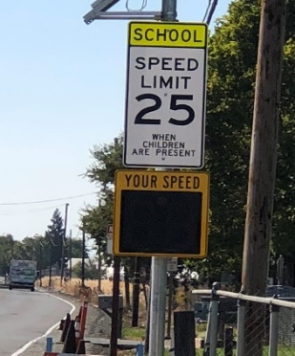
Thank you for sharing your children with me,
Ms. Davis

